Handout: Social networks and care maps for people with long-term conditions

What is a social network?
Each person with a LTC has a social network of people and services who support them. These are called care maps. Some people with LTCs have lots of people and services within their social network. Some people with LTCs will have people and services both inside and outside their social networks. These networks may change over time
Have a look at these two examples of care maps showing social networks. Identify who is inside and outside each person’s network.

Care Map 1

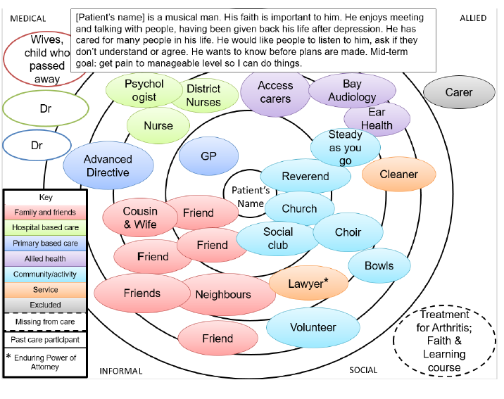

(© Jessica Young, June 2017.)

Care Map 2
This patient has a long history of mental illness and has been hospitalised a number of times. He is currently well and living in the community but knows he must keep taking his medication which is critical to him staying well. He is a religious man and likes living in his small community where he was brought up and where he still has friends and family and a community health worker he can call on for advice. As part of keeping well he keeps daily journals and walks every day. He has been a keen amateur artist for some years as it helps him to cope with his mental illness.

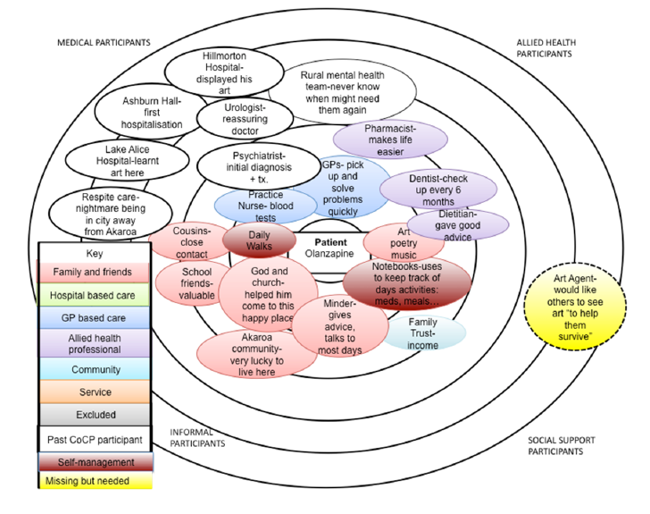

(© Jessica Young, June 2017.)

Social network and care maps for a person with LTCs
Think about one person you work with. Write down their story.

Now fill in the care map to show the person's social networks.
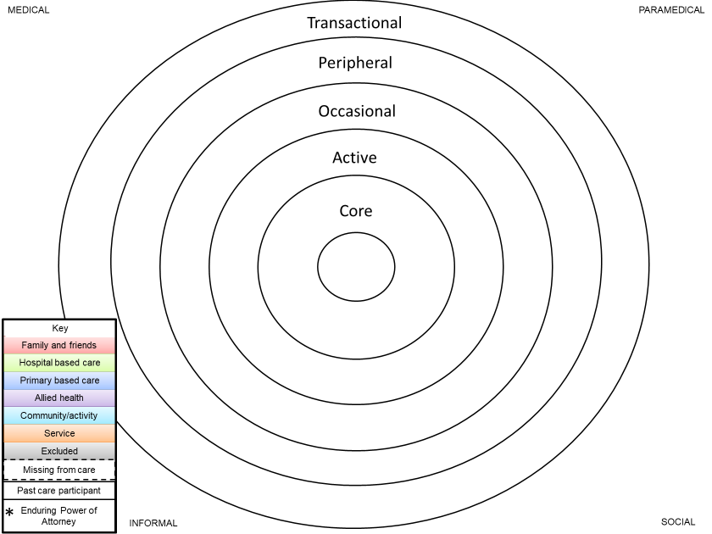

(© Jessica Young, June 2017)

