Ask, Build, Check – Building health literacy skills and knowledge module

Learning objectives for this training session

By the end of this session participants will be able to:

- describe the Ask, Build, Check model
- describe the key features of Ask and why it is the most important step
- describe key features and strategies under the Build step
- describe key features and strategies under the Check step and why it is the hardest step
- practise each of the three steps Ask, Build, Check
- identify when they are going to start using Ask, Build, Check.

Trainer’s Notes

1. Please read this document and the Handout at least a couple of days before the training session. .
2. If possible, this session should be delivered after the Listening and Asking Questions Modules.
3. Please print off enough copies of the Handout for the number of people in the session.
4. You will need to have a laptop or laptops with internet access to show a video in the session. Make sure each participant can see the video clearly.
Video – Teachback: Rheumatologist and Betsy: www.youtube.com/watch?v=jcrLnTT61uY
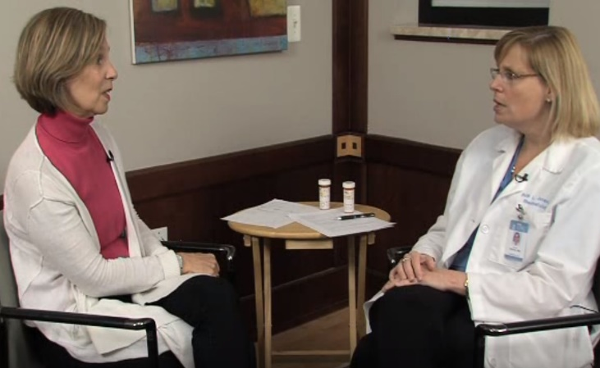

5. Please have a whiteboard or flipchart and some post-it notes available (at least three post-its for each participant.
Purpose and time | Activity | Resources
Welcome everyone to the session.
Explain that this session is going to explain about a Three Step Model Ask, Build, Check to build health literacy skills and knowledge with people and families. Give everyone a copy of the Handout.
Building new knowledge  (15 mins) | Ask: Step 1  Refer participants to the Ask, Build, Check model on the first page of the Handout.  Ask (Step 1) is the most important step (participants need to make sure they do this) and also the easiest to learn. Ask is based on the fact that we all have knowledge about things. Sometimes we know a lot – sometimes we don’t know very much. Before we begin giving people information we need to find out what they already know, think, do and believe so we can add the right kind of information later.  Ask is also based on what is called the ‘Universal Precautions’ approach to health literacy. We can’t tell by looking at people whether they know a little or a lot about something. So, we have to ask to find out what they know about their condition. Ask can also be used to identify all issues that are causing the patient concern (e.g. housing) and then prioritise (see page 2 of the Handout - setting an agenda).  On page 3 there is information about the importance of prior knowledge.  Write on the whiteboard or flipchart the words ‘Baked Beans’. Ask the participants to call out what they know about baked beans. Keep asking until you have a few answers. Then ask participants to put their hands up if they like baked beans. Then ask them to put up their hands if they don’t like baked beans. Ask one of the participants who doesn’t like baked beans to do a very short role-play with you. Ask them to pretend they have Type 2 diabetes and you are their nurse. Ask participants to listen to the two conversations.  Say to the volunteer “For your diabetes I want you to eat baked beans three times a week”. If they screw up their face, make sure the other participants can see the other person screw up their face. If the person says they don’t like baked beans congratulate them for being so assertive and remind participants that people usually don’t say anything.  Then ask the volunteer “Tell me, do you like baked beans?” When they say “no” say “That’s a shame because baked beans can be good for diabetes. Instead let’s talk about the food you do like and work out together what you can eat more of and what you can eat less of. How does that sound?”  Ask participants what they noticed about the two different conversations. Asking what the person liked made a difference rather than the nurse telling the person to do something they weren't going to do. Say to participants “What you saw in the last role play was a set-up for Step 2”. | Page 1, 2, 3 of handout  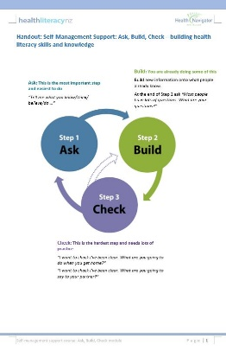  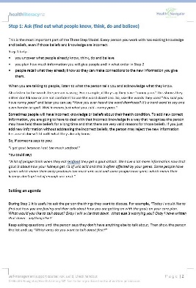  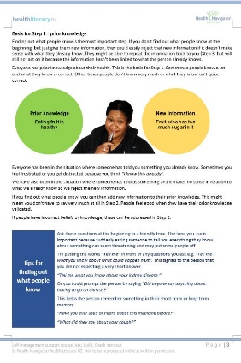
Building new knowledge  (15 mins) | Build: Step 2  Point out we are now at the Build stage (pages 4 and 5 of the Handout) and we think participants are already doing some of this. The whole focus of Step 2 is to build new knowledge on what people already know by linking the new information to what they already know. Give participants time to read the pages.  If necessary, briefly go through the key points for each strategy on page 5.  Logical steps: Should be used for sequences such as using inhaler or blood glucose meter. Use numbers 1, 2, 3, etc. to make it obvious. If participants realise they have forgotten something, start again – don’t say halfway through “Oh sorry, first you need to wash your hands”.  Remind participants that they may be very logical, but people may not be.  Chunks: Ask participants “What’s the maximum number of chunks of information you should give people?” (3-5). After that, their short-term memory is overloaded. And if someone is unwell then their ability to take on information may be even less.  If participants have to give a lot of information at once, provide written resources to support what they are saying and offer to record the conversation on the person’s mobile phone so they can listen to it later.  Ask questions: We have already done a training module about this. Remember make sure you don’t make assumptions.  Explain technical words: Explain to participants that a person has to read, hear, say and write a new word 40 times before that word becomes part of that person’s vocabulary.  In healthcare, there are lots of new words and a lot of them are Greek and Latin. Ask participants if they know what words people have difficulty with and how participants explain them in everyday language.  Use visuals: Ask participants how many use hands-on materials when talking to patients. A lot of health professionals get people to demonstrate how to use their inhaler/spacer/peak flow meter – this is great. Also ask if the person wants the participant to take a photo or video on the person’s phone to help remind them.  Use written resources: Most important thing to do when giving a person a written resource is to explain WHAT to read, WHY to read it, HOW it will help and WHAT to do next. If participants only want the person to refer to part of a book, staple the other pages together. And if necessary, highlight and write on the pages of the booklet so people know what to focus on.  Anticipate next steps: With long-term conditions people will go through a number of phases. Care and management plans help people to anticipate the next steps and feel confident that they are able to manage any deterioration/improvement in their condition. Explain we are going to talk more about care plans later.  Reinforce and emphasise: In healthcare, we spend a lot of time telling people what they have done wrong. We need to find more opportunities to acknowledge what people are doing right, even if it is a small thing. We can also acknowledge that people are experts in their long-term condition and at managing them at home. We need to reinforce and emphasise what people are doing well even if it is only something quite small and then reinforce and emphasise the small steps that people need to take to make changes. | Pages 4 and 5 of handout  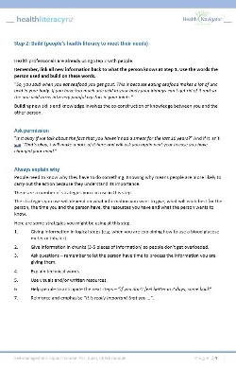
Building new knowledge  (10 mins) | Check (you have been clear): Step 3  Say to participants that this is the hardest step of the Three Step Model (pages 6 and 7 of the Handout). It is important to become very familiar with, and be automatically using, Steps 1 and 2 before they start using Step 3.  Ask participants if they have ever had an appointment with someone and then wondered afterwards if the person understood what the conversation was all about.  Step 3 requires people working in health to think differently about why people aren’t following instructions and doing what they have been asked to do. If people working on health keep thinking that people aren’t doing things because they don’t understand or they lack intelligence, then Step 3 will be a challenge. Step 3 requires people working in health to look in the mirror and say “Maybe my instructions weren’t clear”. Step 3 means the person working in health is responsible for the clarity of their communication and if the person doesn’t understand, then the person working in health has to take responsibility for not being clear e.g. “I’m sorry I wasn’t clear. Let me go over that again”.  The reason why it is important for participants to be confident at using Ask and Build before they use Check is that people may still be able to tell participants what they said in Build, but if participants haven’t linked what they said to what people already know (Ask) then the new information could be ignored because it doesn’t make sense in relation to what the person already knows.  So, start practising Check either at your first or last appointment of the day. If possible, get someone to observe you. Get your ‘script’ right – what words work best for you. Tell the person that you are trying something new. Remember, saying “Have you got any questions” or “Do you understand?” will make the other person feel like they are stupid. | Pages 6 and 7 of handout  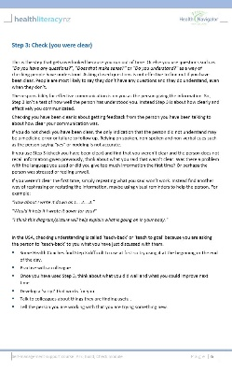
Using the Ask, Build, Check model  (10 mins) | Ask, Build, Check in action  Explain you are going to show them a video of Ask, Build, Check in action. Say it is a good example – not a perfect example. Explain that on the video they talk about ‘Teachback’ which is a US term for Check. In the US, they use a number of terms for the Three Step Model – ‘Ask Tell Ask’ and ‘Closing the Loop’.  Ask participants to watch the video and try and see when the rheumatologist moves from Ask to Build to Check and the words she uses. Play the video.  At the end, ask participants:  - What did the rheumatologist say at the beginning of Ask?  (Tell me how things are going.)  - Did the rheumatologist set an agenda?  (Yes, right at the beginning – Betsy, today we are going to talk about your arthritis.)  - When did the rheumatologist move to Build?  (When she started talking about Betsy’s medicines – so one problem could be …)  - What did the rheumatologist say when she moved to Check?  (Tell me what you are going to do.)  - How many open questions did the rheumatologist ask?  (Only two: Tell me…. at the beginning of Ask and Check).  - There were two occasions when Betsy’s prior knowledge stopped her from doing something. What were they?  (1. Prior knowledge that Prednisone causes weight gain meant she was forgetting to take the Prednisone.  2. Prior knowledge that usual dose of medicines is two tablets at a time meant Betsy did not take Methotrexate as prescribed, even though correct instructions on label.)  - Who was responsible for making sure Betsy understood about the two medicines?  (Rheumatologist and pharmacist).  If you have time ask participants why they think you aid the video wasn’t a perfect example of Ask Build Check. Participants might identify that the rheumatologist’s tone changes once she realises Betsy is not taking her medicines correctly and the rheumatologist also says “should”. | Ask, Build, Check model
Evaluation  (5 mins) | Plus, Minus and Interesting  Make sure everyone has access to three post-it notes. Label the first post-it note ‘P’ (for plus), the second ‘M’ (for minus) and the third ‘I’ (for interesting).  Explain this is an evaluation of the session.  Ask people to write something on each of their three post-its (what was a plus, what was a minus and what was interesting) and then put the post-its up on a wall/whiteboard/tabletop under the three categories.  Take a photo of the responses for your records.
Improvement activity  (5 mins) | Starting to use Ask, Build, Check  Refer each participant to the Ask, Build, Check model (first page of the Handout). Ask each participant when they plan to start using the Ask, Build, Check model and how you can support them do this. | Ask, Build, Check model

