Cultural competence module

Learning objectives for this session

By the end of this session participants will be able to:

- describe what cultural competence is and why it is important
- describe how definitions of cultural competence have changed
- understand that cultural competence is affected by our attitudes and beliefs
- describe a personal bias that they have
- understand that developing cultural competence is an ongoing process
- demonstrate understanding of cultural competence.

Trainer’s Notes

1. Please read this document and the Handout at least a couple of days before the training session.
2. This session should be delivered after the Asking Questions to Stop Making Assumptions and Listening Training Modules.
3. Please print off enough copies of the Handout depending on the number of participants in the session.

Purpose and time | Activity | Resources
Welcome everyone to the session.
Explain that this session is going to be about the importance of cultural competence in self-management support (SMS) and all other situations to make sure we are providing culturally competent care.
Activating prior knowledge  (15 mins) | Why is cultural competence important?  Talk about your practice’s experience of cultural competence training. Staff may have gone to courses or there may have been an in-house session for all staff.  Give everyone a copy of the Handout. Ask everyone to read page 1 about what cultural competence is and why it is important.  Talk through unfairness in the health system that affects the people with LTCs you work with. Start off with one of your own examples e.g. people with LTCs might find it really hard to get to appointments because of transport issues. Then go around and see if participants can identify other examples of unfairness. If not, suggest other examples - takeaways easier to get than healthy food, only housing some people can afford is cold and damp and affects children’s health.  Remind participants that we need to be aware of these examples of unfairness to be culturally competent. | Page 1 of handout  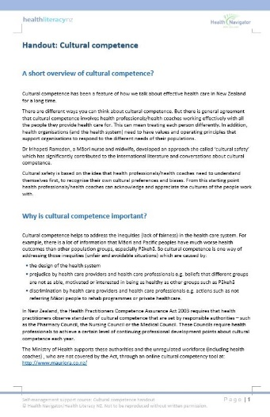
Building new knowledge  (25 mins) | How has cultural competence changed?  Refer everyone to page 3 of Handout about how cultural competence has changed. Point out that definitions of cultural competence have shifted from checklists about working with different cultures to being aware of your own culture and recognising when you need to find out more about the culture of the person you are working with.  Get participants to look at the bullet points at the end of page 3. Ask participants if they have ever had a situation where they realise that they don’t have the same beliefs as a person with LTCs they are working with. Give an example from your own practice e.g. a person with LTCs you are working with who says they will do something but they never do and it makes you feel cross/less interested in helping them. Explain that is your personal bias and to overcome that bias you need to find out what is really stopping the person from doing what they said they would do. Maybe they are saying things to make you happy, maybe the person has no idea about why it is important, maybe it is not a priority, or that there are too many barriers to completing this action.  See if participants have other examples. Ask them to identify their personal biases in each example.  Refer everyone to page 4 about what cultural competence isn’t. Go through each item carefully. Make sure people understand each example and the beliefs that underpin each item.  Now refer everyone to the section about implicit bias on page 5. Point out that our biases come from our background, family and friends as well as the media. The most important thing about biases is becoming aware of them (consciously being able to recognise them) . That way when you are under pressure you are much more likely to stop and think, and then ask questions about something you don’t understand rather than going back to old ways of thinking.  Go around the group and ask them to give an example of a bias or belief they might have – start off with your own example e.g. I like to work with people who act on what they say, as it shows me that their health is important to them. | Page 3, 4, 5 of handout  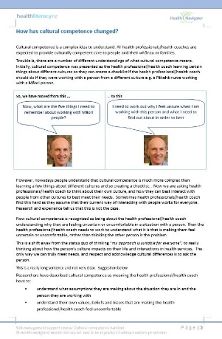  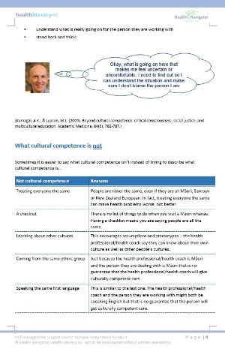  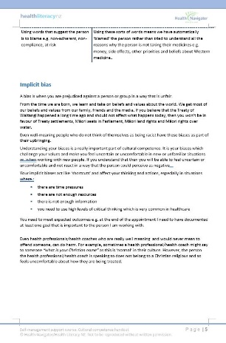
Building new knowledge  (10 mins) | Can you ever be totally culturally competent?  Refer everyone to the Pharmacy Council’s statement on cultural competence on page 6 of the Handout. Point out that the statement says:  cultural competence is a process that can take a long time we might never be culturally competent because we can never guess all the situations we are going to find ourselves in.  So, we need to rely on thinking about who we are, including our attitudes and beliefs, to provide culturally competent care.  Refer people to The Medical Council of New Zealand’s list of cultural competencies on pages 6 and 7. Say this is a reference for participants. | Page 6, 7 of handout  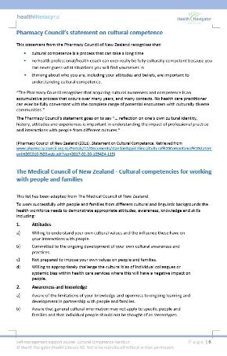  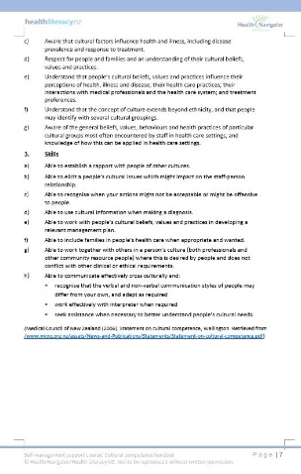
Building new knowledge  (5 mins) | What can I do to be more culturally competent?  Refer everyone to page 8 of the Handout.  Go around the participants and ask if any of the points on this page are something they could try. | Page 8 of handout  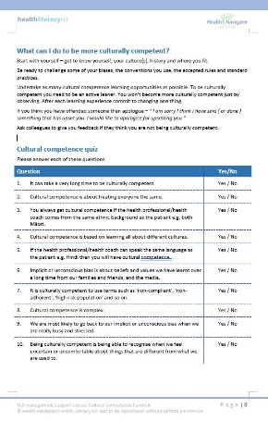
Evaluation and improvement activity  (5 mins) | Cultural competence quiz  Refer everyone to the quiz on page 8 of the Handout and get them to fill it in.  Quickly go through the answers.  Question Yes/No  1. It can take a very long time to be culturally competent. Yes  2. Cultural competence is about treating everyone the same. No  3. You always get cultural competence if the health professional/health coach comes from the same ethnic background as the patient e.g. both Māori. No  4. Cultural competence is based on learning all about different cultures. No  5. If the health professional/health coach can speak the same language as the patient e.g. Hindi then you will have cultural competence. No  6. Implicit or unconscious bias is about beliefs and values we have learnt over a long time from our families and friends, and the media. Yes  7. It is culturally competent to use terms such as ‘non-compliant’, ‘non-adherent’, ‘high risk population’ and so on. No  8. Cultural competence is complex. Yes  9. We are most likely to go back to our implicit or unconscious bias when we are really busy and stressed. Yes  10. Being culturally competent is being able to recognise when we feel uncertain or uncomfortable about things that are different from what we are used to. Yes /  Ask each participant about one thing they are going to do differently in relation to cultural competence. Make a note of this for your records.  Thank people for participating. | Page 8 of handout  