Social networks, care maps and supports for people with long-term conditions module

Learning objectives for this session

By the end of this session participants will be able to:

- describe a social network fora person with long-term conditions (LTCs)
- identify the social networks and supports for different people with LTCs
- describe a social network and develop a care map for a person they work with who has LTCs.

Trainer’s Notes

1. Please read this document and the Handout at least a couple of days before the training session.
2. Please print out enough copies of the Handout for the number of participants. The Handout really needs to be printed in colour to make the key to the Social Networks obvious.
3. Think of some examples of people with LTCs in your practice who have social networks to support them.
4. Please have a whiteboard or flipchart available and at least three post-it notes for each participant for the evaluation activity.
5. Complete the Certificate of Attendance on the last page of this Training Plan for each participant.

Purpose and time | Activity | Resources
Welcome everyone to the session.
Explain that this session is about social networks for people with LTCs.
Activating prior knowledge  (15 mins) | Social networks  Write up on a whiteboard or flipchart ‘Social networks for people with LTCs’.  Ask participants if they can give examples of social networks that support people with LTCs in their practice. If necessary, give some examples e.g. family, friends, carers, clubs. Write participants’ ideas up on the whiteboard.  Explain that social networks provide really important support for people with LTCs.  Ask participants how each example of a network written up on the whiteboard (e.g. family) can assist a person with LTCs e.g. shopping, with transport to appointments, social involvement, getting people out of the house and so on.
Building new knowledge  (20 mins) | Examples of social networks and care maps  Give everyone a copy of the Handout and ask them to look at page 1. Explain that a student from Otago University, Jessica Young, completed her PhD about social networks of people with LTCs and how becoming aware of people’s social networks could help primary care staff be more aware of who and what helps people. The completed document is called a care map.  Get participants to look at the care map on page 1 as well as the key to the different social networks. Then go around and identify what participants’ see – who is close, who is a long way away, what surprises people?  Examples of discussion points:  - Cleaner much closer than carer – why is that? Do we assume that because the carer is there every day that that will result in a close relationship.  - Faith is important so church, reverend and choir are close.  - Hasn’t got any close family – only cousin and wife.  - More friends in social network and they are close to him  - Appreciates range of health professionals who help him but apart from GP they are not very close to him.  Then get participants to look at the second care map on page 2. This time, ask them to identify social networks and also identify how the participants think the social networks support this man. Give participants 5 minutes to do this and then go around the group and ask for ideas.  This man has social networks that are key forms of self-care as well as providing social connections. This is a good example of a social network for someone with long term mental illness as the networks are extensive so he has a number of groups for support. Examples include:  - Close community (cousins and school friends) where he has lived all his life – knows people and they know him so he is not socially isolated  - Faith and church assist him to feel mentally settled and well and not socially isolated  - His art, poetry and music help him mentally and spiritually – major form of self-care  - Daily activities to keep him physically. This is an ideal social network for well and connected with his community – major form of self-care  - Pharmacist because taking medication so important to man staying well  - Minder who is a regular contact and helps with problem solving  - (helps to make sure he is not socially isolated)  - Primary care staff to help him if problems arise  - Diaries so he has a record of what has happened during the day  - Mental health professionals are not as close but are still there in case he needs assistance  - Income from a family trust mean he doesn’t have to worry too much about money  At the end, ask participants if they think this information would be useful to them when working with a person with LTCs to:  - know what is important to the person  - know who supports the person and how  - know how relevant health professionals are  - understand how relevant LTC medicines and treatments are  - understand how important the local community is  - know what has changed recently. | Page 1 & 2 of handout  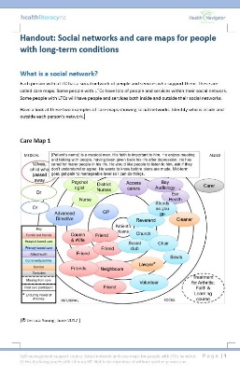  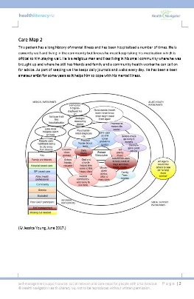
Building new knowledge  (20 mins) | Developing a care map for a person with LTCs  Ask participants to go to page 3 of the Handout and complete a care map for a person with LTCs they work with. Participants could work in pairs if that works better.  If participants want to know what transactional and peripheral mean in terms of the care map, refer them to the previous examples in the Handout so they can see what relationships/people are on the outside of the circles of the care map. Give people 5-10 minutes to complete the care map.  Go around the group and ask what they found from completing this process – what did they know about the person, were they able to complete a care map, what else would it have been useful to know, how useful would a care map be for their work with people with LTCs and in what way.  Remind participants they would need to confirm the care plan with the person to make sure it is correct rather than assume that what participants have written is correct. | Page 3 of handout  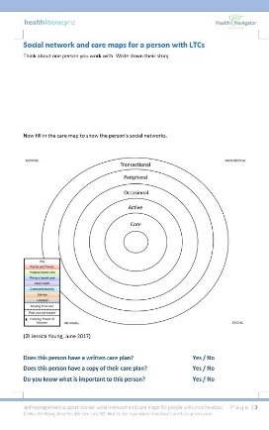
Evaluation  (5 mins) | Plus, Minus and Interesting  Explain this is an evaluation of the session.  Make sure everyone has three post-it notes. Ask participants to label the first post-it note ‘P’ (for plus), the second ‘M’ (for minus) and the third ‘I’ (for interesting).  Ask people to write something on each of their three post-its (what was a plus, what was a minus and what was interesting) and then put the post-its up on a wall/whiteboard/table top under the three categories.  Take a photo of the responses for your records.
Certificate of Attendance

Please complete the certificate on the last page of this Training Plan for each of the participants.

