Structured problem-solving & decision-making module

Learning objectives for this training workshop

By the end of this session participants will be able to:

- identify and use at least two strategies participants can use when providing SMS support for people with LTCs

Facilitator notes

- This short module should take 15 minutes to deliver.
- Prepare the handouts depending on the number of people attending the session.
- There is an optional video that describes the structured problem-solving process. It takes 9 minutes and can be shown at the end of the session if time allows.
- Video can be accessed here https://www.healthnavigator.org.nz/videos/s/self-management/structured-problem-solving/

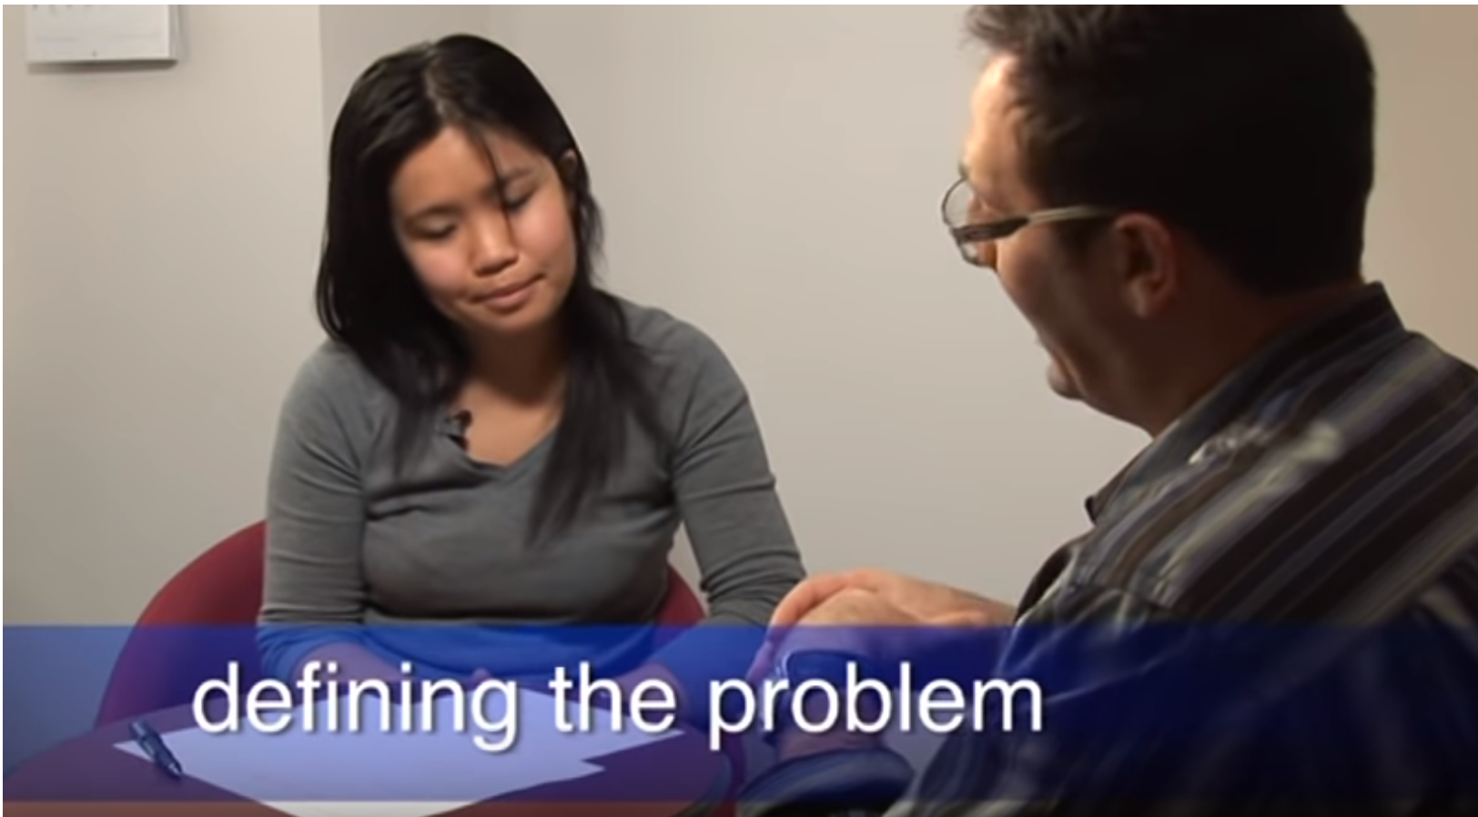
https://youtu.be/iCoPbbLQ5m4

Topic | Activity description and facilitator guide | Resources
Welcome everyone to the session.
Explain that this session is going to explain about two strategies you can use to provide Self-Management Support (SMS) to people with long-term conditions (LTCs) to assist them to manage their health.

Key SMS strategies- Problem solving and decision making

Write up on a whiteboard or flipchart one under each other:
- Problem-solving
- Decision-making
- Ask participants who uses these strategies with people with LTCs.
- Ask participants which strategy they prefer and why.
- Ask participants if there are any other strategies participants use. Write any other strategies on the whiteboard/flipchart.

Structured problem-solving  activity | Structured problem-solving activity  - Ask the group to work in pairs  - Give the handout to participants  - Go through the step by step process and worked example on page 1 of the handout.  - Ask participants to work through the case study (below) using the ‘problem solving’ work sheet (page 2). Follow the process through to step 5 – make a simple action plan (allow 5 minutes)  Case study – write this up on the flipchart or whiteboard  One of the people you have been working with exercises for 15 minutes, three days a week. He has Type 2 diabetes, high blood pressure and high cholesterol. His family has a history of kidney disease.  You have been encouraging him to increase the amount of exercise that he does but he’s not sure if he can do it. | Page 1 & 2 of handout  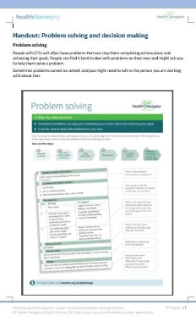  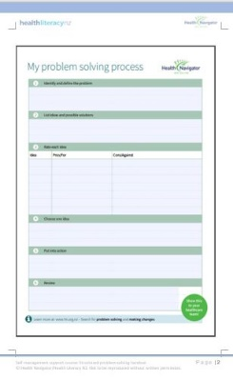
Decision-making | Decision-making activity  Go through the decision-making process on page 3 of the handout. Use an example case study from your practice and ask the participants to consider the decision to be made and to complete the blank template at the bottom of the page. | Page 3 of handout  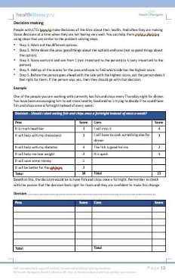
 | Ask participants if they have any questions about what you have covered in this training session. Where appropriate, ask other participants for their solutions to participant’s questions.

